Dear Students and Parents,
Please allow me to take a moment to welcome you to Castle Dome Middle School for an exciting and eventful eighth grade year. My name is Cary Fields and I will be your child’s Language Arts teacher. This will be my fourteenth year teaching, my sixth at Castle Dome. As the years have come and gone, the excitement and anticipation I feel with beginning a new school year never seems to lessen. It is even more special for me this year, as our school will be implementing several new technology-related programs.
During this first week of school, my students will have the opportunity to cover some rules and expectations for my class. I wanted to send a copy of what we discussed for you to keep at home, so that through working as a team, we can ensure that your child finds success in my classroom.
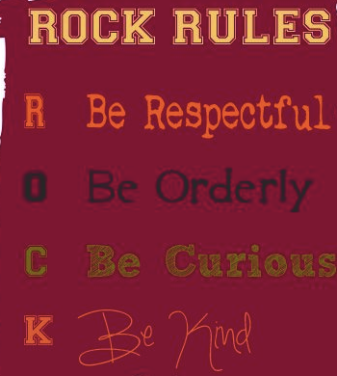
As you can see, these rules are pretty simple to remember and apply to many things. Thank you in advance for encouraging your child to R.O.C.K. the Rules!

My classroom expectations are as follows:
Be Prepared
Please bring to class each day a pencil, 3 ring binder with loose-leaf paper, and free read book.

Accessibility of lessons
Most of my lessons will be available in video form. This means your child can access a specific topic watch the lesson, rewind and watch again to be certain they understand.

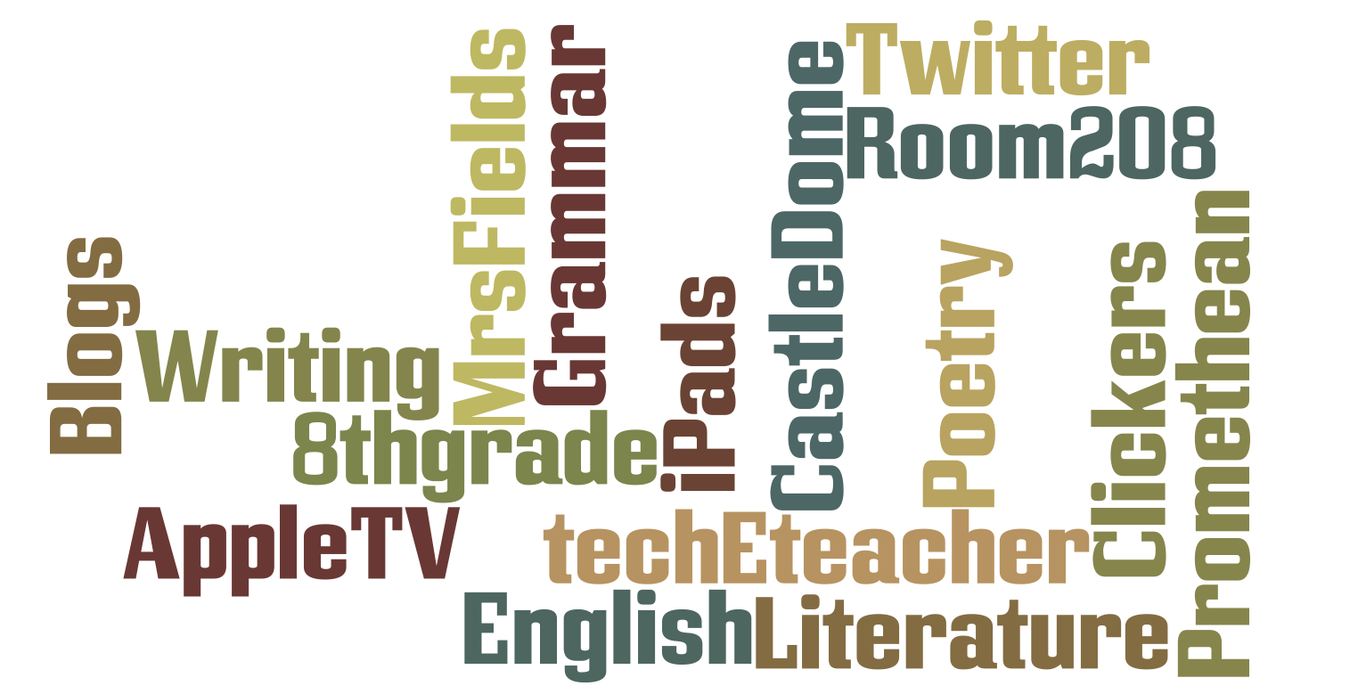
Edmodo
Many of the assignments I give to students will be via a closed online environment, which allows students to interact, collaborate and watch short video lessons and even take quizzes.
Turning in assignments
Turn in work when it is due. If assignments are frequently turned in late or missing, I will contact the parents to advise them of my concerns. In the event of an absence, the student will need to personally contact me at a convenient time upon return to school to receive make-up work.
My grading policy
I don’t accept late work. (Of course, if a student has an excused absence, the school’s policy is followed.)
In addition, we will have some repeating assignments that are given on a regular basis throughout the school year. Daily Language is a regular activity that will be assigned throughout the school year. Daily Language is completed in class and focuses on the basics of correct grammar, spelling, punctuation and mechanics.

We will be using several Web 2.0 tools in class. I will be sending a Technology Informational letter home later in the week with more details and links.

BYOD – Bring Your Own Device is a new program we are starting at Castle Dome. What this does is allows students to bring their iOS device, cell phone or Android to school and use it for educational purposes. I hope you will join me in encouraging your child responsible digital citizenship by following guidelines set in place by the administration. It is an exciting time to be a student specifically at Castle Dome. I am thrilled to have the opportunity to promote student use tech tools as part of their educational journey.
Finally, in order to encourage communication between parents, students, and myself, I have created a class website that contains a great deal of information relating to my Language Arts classes. The address for this site is http://mrsfieldsenglish.weebly.com I will make every attempt to keep this site updated with weekly assignments and other important information relating to our class.
I welcome and encourage open communication amongst the parent, student and teacher. Please don’t hesitate to call me at CDMS Phone Number should you have any questions or concerns relating to your child or my class. You can also email me at cfields@yumaed.org if this is more convenient.
Again, I want to welcome you to CDMS and to my class. I am looking forward to working with your child and you throughout the upcoming school year.
Sincerely,
Cary Fields
8th Grade Language Arts Teacher
Castle Dome Middle School

